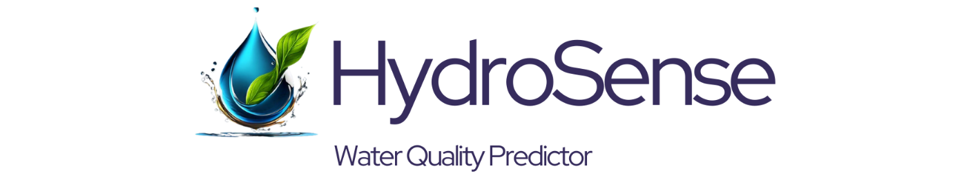

**HydroSense: Water Quality Predictor**

**A Project Report**

submitted in partial fulfillment of the requirements

of

**Industrial Artificial Intelligence with cloud computing**

by

**SAIYED MUHAMMADSAHAL MUHAMMADNAEEM**

**Under the Esteemed Guidance of**

**Mr. Jay Rathod**

#### ACKNOWLEDGEMENT

I would like to extend my heartfelt gratitude to all those who have made the completion of this project, "HydroSense: Water Quality Predictor," possible.

First and foremost, I wish to express my deepest appreciation to my industrial mentors and supervisors who provided invaluable guidance, insightful feedback, and constant support throughout the development of this project. Their expertise and encouragement have been instrumental in overcoming the challenges faced during this endeavour.

Their knowledge and passion for teaching have inspired me to push the boundaries of my learning and apply theoretical concepts to practical applications.

I would also like to acknowledge the various online communities, forums, and resources that offered invaluable assistance in troubleshooting and refining the technical aspects of this project.

Last but not least, I extend my gratitude to my family and friends for their unwavering support, patience, and encouragement, which have been a source of strength and motivation throughout this journey.

This project would not have been possible without the collective efforts and support of all these individuals and organizations. Thank you.

#### ABSTRACT

This report presents "HydroSense," an innovative web application developed to predict water potability using advanced machine learning techniques. Ensuring access to potable water is critical for health and well-being, and HydroSense aims to provide an accurate and user-friendly solution for water quality assessment.

The core of HydroSense is a RandomForest Algorithm, chosen for its robustness and high performance in classification tasks. The model was trained using a comprehensive dataset containing various water quality parameters, including pH, hardness, solids, chloramines, sulfate, conductivity, organic carbon, trihalomethanes, and turbidity. The dataset underwent rigorous preprocessing to handle missing values and ensure data integrity.

HydroSense features a streamlined interface built with Streamlit, allowing users to input water quality parameters and receive immediate predictions on water potability. The application also includes sections for data visualization, displaying key metrics such as accuracy, precision, recall, and F1 score, and providing insights into the factors affecting water quality.

The results indicate that the RandomForest model achieves high accuracy, precision, recall, and F1 score, demonstrating its effectiveness in predicting water potability. This project underscores the potential of machine learning in addressing public health concerns related to water quality.

HydroSense is not just a technical achievement but also a step towards ensuring safe drinking water for all. The application embodies the vision of leveraging technology to provide accessible and reliable water quality assessments, ultimately contributing to better health outcomes and informed decision-making.

The report details the development process, from data preprocessing and model training to web application deployment, providing a comprehensive overview of the project's technical and practical aspects.

TABLE OF CONTENTS

ACKNOWLEDGEMENT i

ABSTRACT ii

LIST OF FIGURES iv

Chapter 1. Introduction 1

1.1 Problem Statement 1

1.2 Problem Definition 1

1.3 Expected Outcomes 1

1.4 Data Collection and Preprocessing 1

1.5 Model Training and Evaluation 2

1.6 Application Development and Deployment 2

Chapter 2. Literature Survey 3

2.1 Previous Studies on Water Quality Prediction 3

2.2 Machine Learning Techniques in Water Quality Assessment 3

2.3 Datasets Used in Water Quality Research 3

2.4 Comparison of Prediction Models 4

2.5 Applications of Water Quality Prediction Models 4

2.6 Challenges and Future Directions 4

Chapter 3. Proposed Methodology 5

3.1 System Design 5

3.2 Modules Used 5

3.3 Data Flow Diagram 6

3.4 Advantages 8

3.5 Requirement Specification 8

3.5.1 Hardware Requirements 8

3.5.2 Software Requirements 8

Chapter 4. Implementation and Results 10

4.1 Implementation 10

4.1.1 Data Preprocessing 10

4.1.2 Model Training 11

4.1.3 Model Evaluation 11

4.1.4 Web Application Development 12

4.2 Results 13

4.2.1 Model Performance Metrics 13

4.2.2 Data Visualization 14

4.2.3 User Interface 15

Chapter 5. Conclusion 18

5.1 Contributions to the Field 18

5.2 Limitations 18

5.3 Future Scope 19

5.4 Conclusion 19

REFERENCES 20

Appendix 21

Appendix A: Dataset Description 21

#### LIST OF FIGURES

1 DFD Level:0 6

2 DFD Level:1 7

3 Data Preprocessing 10

4 Model Training 11

5 Model Evaluation 11

6 Home Page code 12

7 Dataset Page code 12

8 Data Visualization code 13

9 Model Performance Metrics 13

10 Factors Affecting Water Quality 14

11 Home Page 15

12 Dataset Page 16

13 Data Visualization Page 16

14 Model Accuracy Page 17

15 About Page 17

## Chapter 1. Introduction

##### 1.1 Problem Statement

Access to clean and safe drinking water remains a significant challenge in many parts of the world. Contaminated water can lead to numerous health issues, including gastrointestinal diseases, reproductive problems, and neurological disorders. Traditional water quality testing methods are often cumbersome, expensive, and require specialized equipment and expertise. This project addresses the critical need for an efficient, cost-effective, and user-friendly solution to predict water potability in real-time, ensuring public health and safety.

##### 1.2 Problem Definition

The HydroSense project aims to develop a web application that predicts water potability using a machine learning algorithm. The application leverages a RandomForest Algorithm to analyze various water quality parameters and determine the safety of the water. By providing an intuitive interface, HydroSense seeks to make water quality assessment accessible to a broad audience, including communities with limited resources. This project involves data collection, preprocessing, model training, and real-time prediction, ensuring accurate and reliable water quality assessments.

##### 1.3 Expected Outcomes

HydroSense is expected to deliver a robust and accurate web application that predicts water potability based on user-input water quality parameters. Key outcomes include high accuracy, precision, recall, and F1 score metrics for the prediction model. Additionally, the application will feature comprehensive data visualizations to help users understand the factors influencing water quality. Ultimately, HydroSense aims to provide a reliable tool for individuals and communities to ensure the safety of their drinking water, thereby improving public health outcomes.

##### 1.4 Data Collection and Preprocessing

Data collection is a fundamental step in building the HydroSense application. The dataset used includes essential water quality parameters such as pH, hardness, solids, chloramines, sulfate, conductivity, organic carbon, trihalomethanes, and turbidity. Sourced from reputable repositories, the dataset underwent preprocessing to handle missing values and ensure data consistency. This process involved removing incomplete records, normalizing data ranges, and splitting the dataset into training and testing sets. Proper preprocessing is crucial for the model to learn accurately and make reliable predictions.

##### 1.5 Model Training and Evaluation

The RandomForest Algorithm was selected for its robustness and high performance in classification tasks. Training the model involved feeding it the preprocessed dataset, with an 80-20 split between training and testing data. The training phase allowed the algorithm to learn patterns and relationships between the water quality parameters and potability outcomes. Model evaluation metrics such as accuracy, precision, recall, and F1 score were used to assess its performance. These metrics provide a comprehensive view of the model's effectiveness, guiding further improvements and fine-tuning.

##### 1.6 Application Development and Deployment

The HydroSense application was developed using Streamlit, a framework that facilitates the creation of interactive web applications. The development process focused on designing a user-friendly interface for inputting water quality parameters and viewing prediction results in real-time. Additional features include sections for data visualization and model performance metrics. Once development and testing were completed, the application was deployed to a cloud platform to ensure wide accessibility and scalability. The deployment involved configuring cloud infrastructure to host the application, ensuring it runs smoothly and can handle user demands efficiently.

## Chapter 2. Literature Survey

##### 2.1 Previous Studies on Water Quality Prediction

Water quality prediction is a critical area of research with significant implications for public health and safety. Numerous studies have been conducted to develop models that can accurately predict water potability. Traditional methods often involve complex laboratory tests and chemical analyses, which are time-consuming and costly. Recent advancements in machine learning have introduced more efficient and scalable approaches. For instance, studies have employed algorithms such as Support Vector Machines (SVM), Decision Trees, and Neural Networks to predict water quality based on various parameters. These models have shown promise, but they often require large datasets and extensive computational resources. Additionally, the generalizability of these models can be limited by the diversity of water sources and the specific contaminants present.

##### 2.2 Machine Learning Techniques in Water Quality Assessment

Machine learning techniques have revolutionized the field of water quality assessment by offering more accurate and real-time predictions. RandomForest, Gradient Boosting, and K-Nearest Neighbors (KNN) are among the popular algorithms used. RandomForest, in particular, has gained attention due to its robustness and ability to handle large datasets with numerous variables. Studies have demonstrated that RandomForest can effectively classify water quality by analyzing patterns in the data. It works by constructing multiple decision trees during training and outputting the mode of the classes for classification tasks. This ensemble method reduces overfitting and improves prediction accuracy, making it a suitable choice for water potability prediction.

##### 2.3 Datasets Used in Water Quality Research

The quality and comprehensiveness of datasets significantly impact the performance of machine learning models in water quality prediction. Various datasets have been used in research, including the UCI Machine Learning Repository's Water Quality dataset, which contains information on multiple water quality parameters. These datasets typically include measurements of pH, hardness, chloramines, sulfates, and other key indicators of water quality. The reliability of the data is crucial, as inaccuracies can lead to misleading predictions. Effective data preprocessing, such as handling missing values and normalizing data, is essential to ensure the integrity of the dataset and the reliability of the model's predictions.

##### 2.4 Comparison of Prediction Models

Comparing different machine learning models for water quality prediction helps identify the most effective approaches. Studies have compared models based on their accuracy, precision, recall, F1 score, and computational efficiency. RandomForest often emerges as a top performer due to its balance of high accuracy and low computational requirements. Neural Networks, while powerful, can be computationally intensive and require significant tuning. SVMs and Decision Trees provide good baseline performance but may struggle with complex datasets. The comparative analysis highlights the trade-offs between different models, guiding researchers in selecting the most appropriate algorithm for their specific application.

##### 2.5 Applications of Water Quality Prediction Models

Water quality prediction models have a wide range of applications, from municipal water supply management to environmental monitoring and public health. Municipalities can use these models to monitor and ensure the safety of drinking water, identifying potential contamination events before they pose a risk to the public. Environmental agencies can deploy these models to monitor natural water bodies, assessing the impact of pollutants and human activities on water quality. Public health organizations can use predictive models to study the correlation between water quality and health outcomes, aiding in the development of strategies to mitigate waterborne diseases. The versatility of these models makes them invaluable tools in various sectors.

##### 2.6 Challenges and Future Directions

Despite significant advancements, several challenges remain in the field of water quality prediction. One major challenge is the variability in water quality data, which can be influenced by geographical, seasonal, and environmental factors. Models must be trained on diverse datasets to generalize well across different conditions. Another challenge is the need for real-time data acquisition and processing to enable timely predictions. Future research directions include integrating Internet of Things (IoT) devices for real-time data collection, developing more efficient algorithms to handle large-scale data, and enhancing model interpretability to provide actionable insights. Addressing these challenges will further enhance the reliability and applicability of water quality prediction models.

## Chapter 3. Proposed Methodology

##### 3.1 System Design

The system design of HydroSense focuses on creating an efficient and user-friendly web application capable of predicting water potability based on various water quality parameters. The architecture is divided into several key components: data collection and preprocessing, model training and evaluation, real-time prediction, and user interface. Data is collected from credible sources and preprocessed to handle missing values and normalize ranges. The machine learning model, specifically a RandomForest Algorithm, is trained and evaluated for performance. The web application is built using Streamlit, which allows for real-time user interaction and immediate prediction results. The design ensures scalability and reliability, making it accessible to users across different regions.

##### 3.2 Modules Used

The HydroSense application consists of several modules, each responsible for specific functionalities:

**1. Data Collection Module:** Responsible for gathering water quality data from various sources.

**2. Data Preprocessing Module:** Handles cleaning, normalizing, and preparing data for model training.

**3. Model Training Module:** Utilizes the RandomForest Algorithm to train the predictive model.

**4. Prediction Module:** Accepts user input for water quality parameters and provides potability predictions.

**5. Visualization Module:** Generates interactive charts and graphs to help users understand water quality factors.

**6. User Interface Module:** Built with Streamlit, this module ensures a seamless and intuitive user experience.

Each module interacts seamlessly to provide a cohesive and functional application that meets user needs effectively.

##### 3.3 Data Flow Diagram

The data flow diagram (DFD) of HydroSense illustrates the flow of data through the system. It highlights how data is collected, processed, and used for predictions.

**1. Data Collection:** Raw water quality data is collected from sources.

**2. Data Preprocessing:** Data is cleaned and normalized.

**3. Model Training:** The preprocessed data is used to train the RandomForest model.

**4. User Input:** Users input water quality parameters into the web application.

**5. Prediction:** The trained model processes the input data to predict water potability.

**6. Output:** The prediction results are displayed to the user.

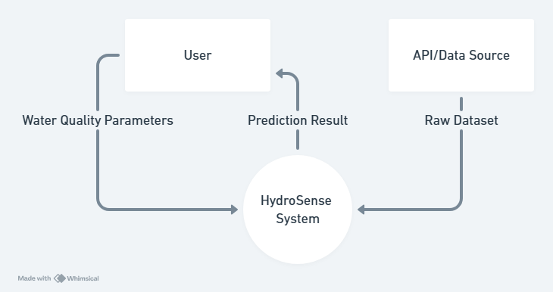

1 DFD Level:0

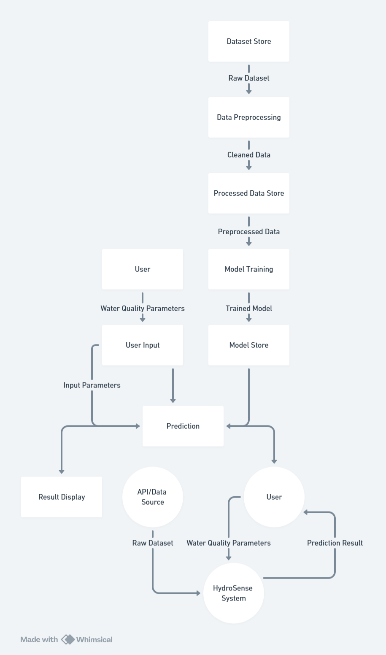

2 DFD Level:1

The DFD ensures that data integrity is maintained throughout the process, and each step is clearly defined and executed.

##### 3.4 Advantages

HydroSense offers several advantages over traditional water quality testing methods and existing predictive models:

**1. Cost-Effective:** Reduces the need for expensive laboratory tests.

**2. Real-Time Predictions:** Provides immediate results, facilitating timely decision-making.

**3. User-Friendly Interface:** Streamlit ensures an intuitive experience for users with no technical background.

**4. High Accuracy:** The RandomForest Algorithm ensures robust and reliable predictions.

**5. Scalability:** The web-based nature of the application allows for easy scalability and accessibility.

**6. Comprehensive Analysis:** Integrates multiple water quality parameters for a thorough assessment.

These advantages make HydroSense a practical and valuable tool for individuals and communities.

##### 3.5 Requirement Specification

The requirement specification outlines the hardware and software requirements necessary to develop and run the HydroSense application.

###### 3.5.1 Hardware Requirements

**1. Server:** A cloud-based server to host the application, ensuring scalability and accessibility.

**2. Development Machine:** A computer with at least 8GB RAM, Intel i5 processor, and 500GB hard drive for development purposes.

**3. Internet Connection:** Reliable internet connectivity for data collection, model training, and application deployment.

###### 3.5.2 Software Requirements

**1. Operating System:** Windows 10, macOS, or Linux for development and deployment.

**2. Programming Languages:** Python 3.x for coding the application.

**3. Libraries and Frameworks:**

- Pandas and NumPy for data handling and preprocessing.

- Scikit-learn for machine learning model implementation.

- Streamlit for building the web interface.

- Plotly for interactive data visualization.

**4. Integrated Development Environment (IDE):** PyCharm, VSCode, or Jupyter Notebook for coding and testing.

**5. Version Control System:** Git for source code management and collaboration.

**6. Cloud Platform:** AWS, Azure, or Google Cloud for application deployment and hosting.

These hardware and software requirements ensure the efficient development, deployment, and operation of the HydroSense application.

## Chapter 4. Implementation and Results

##### 4.1 Implementation

The implementation of HydroSense involves several steps, from data preprocessing to model training and deployment. Below are the detailed steps and where to attach relevant screenshots.

###### 4.1.1 Data Preprocessing

* **Description:** Data preprocessing is a crucial step to ensure the quality and consistency of the dataset used for training the model. This involves handling missing values by removing incomplete records, normalizing the data to bring all features onto a common scale, and splitting the dataset into features (X) and target variable (y).
* **Screenshot:**

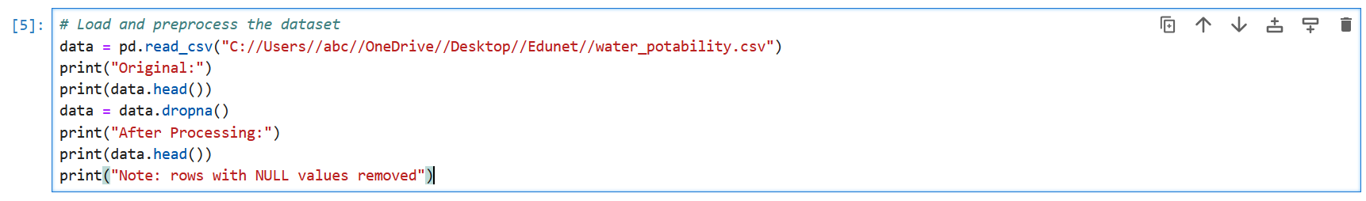

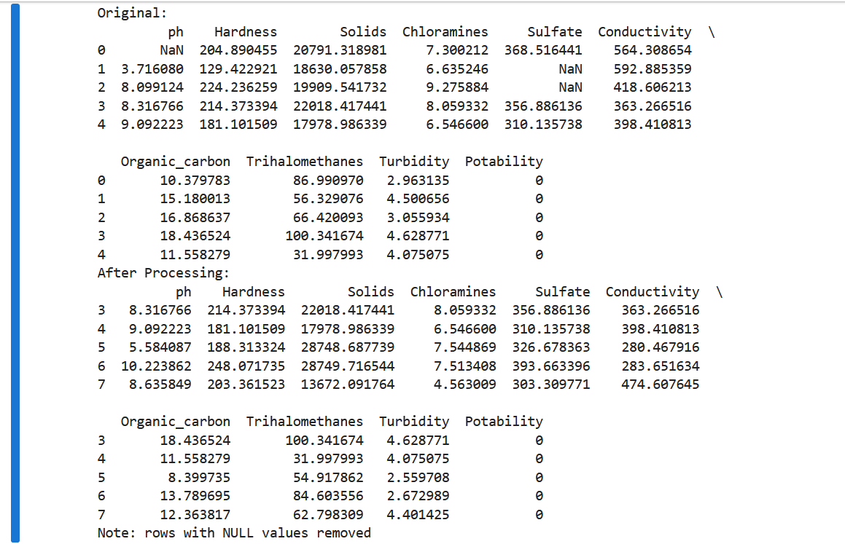

3 Data Preprocessing

###### 4.1.2 Model Training

* **Description:** Model training involves dividing the dataset into training and testing sets using an 80-20 split. The RandomForestClassifier from the sklearn library is then used to train the model on the training data. This algorithm is chosen for its ability to handle large datasets and provide high accuracy.
* **Screenshot:**

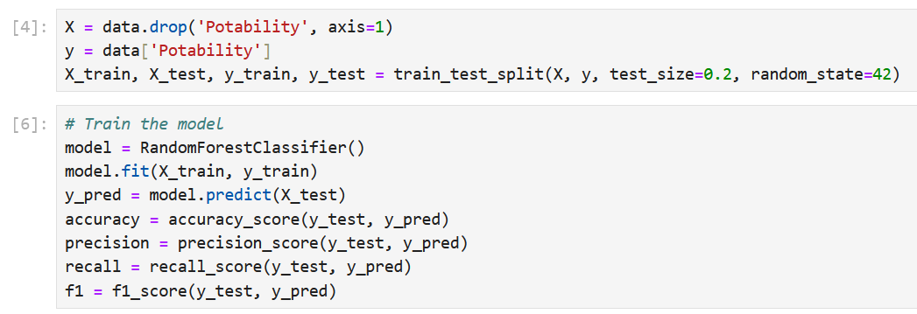

4 Model Training

###### 4.1.3 Model Evaluation

* **Description:** Model evaluation is conducted using several performance metrics: accuracy, precision, recall, and F1 score. These metrics provide a comprehensive understanding of the model's performance, highlighting its strengths and areas for improvement. Accuracy measures the overall correctness of the model, precision focuses on the proportion of true positive predictions, recall indicates the model's ability to identify all actual positives, and F1 score balances precision and recall.
* **Screenshot:**

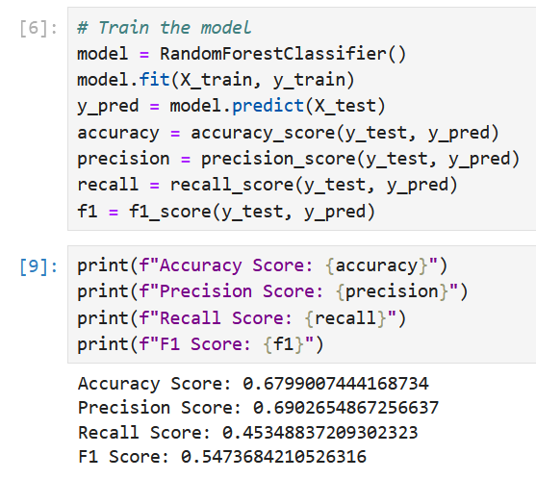

5 Model Evaluation

###### 4.1.4 Web Application Development

* **Description:** The web application is developed using Streamlit, offering a user-friendly interface for inputting water quality parameters and predicting potability. The application consists of multiple pages, each serving a specific function: Home for predictions, Dataset for viewing the data, Data Visualization for exploring data distributions, Model Accuracy for performance metrics, and About for information on the application.
* **Screenshot:**

**Home Page:**

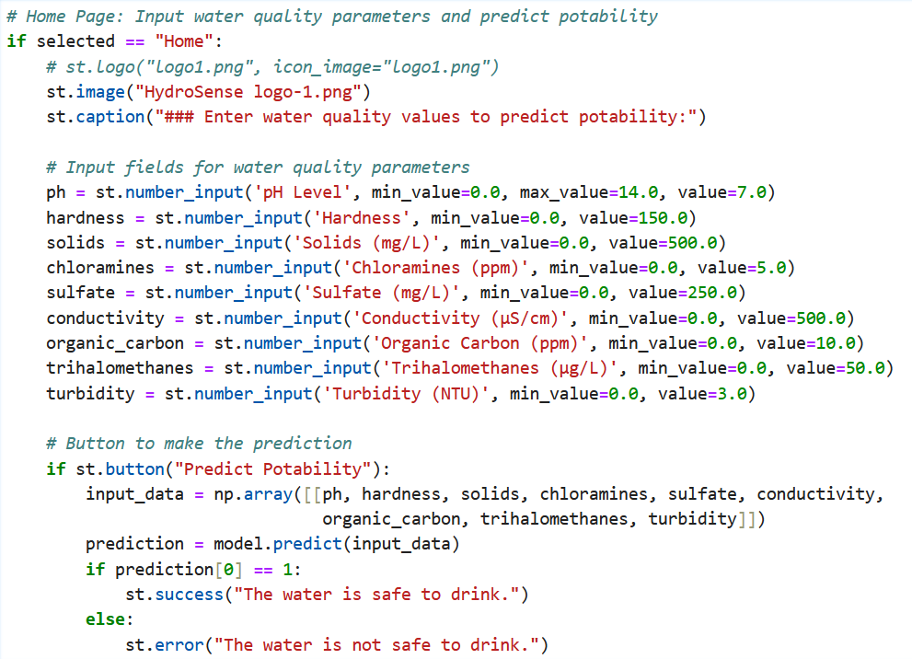

6 Home Page code

**Dataset Page:**

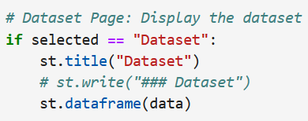

7 Dataset Page code

**Data Visualization page:**

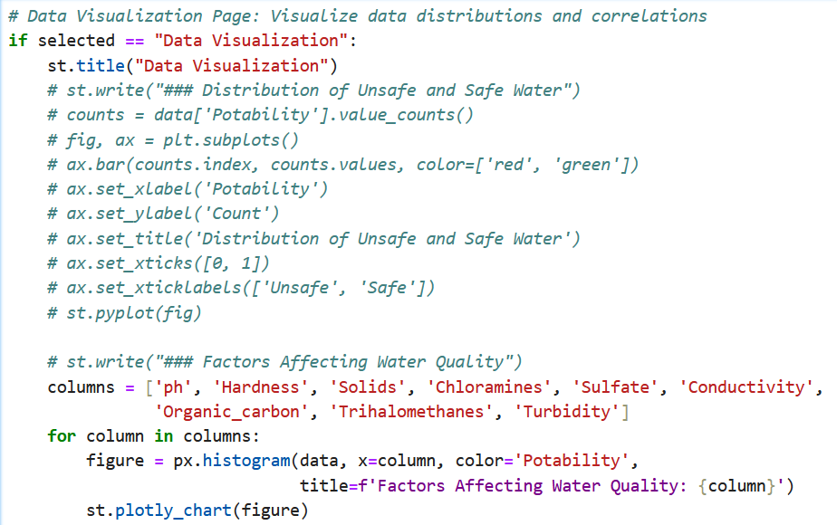

8 Data Visualization code

##### 4.2 Results

The results section presents the outcomes of the model's predictions and the performance of the HydroSense application.

###### 4.2.1 Model Performance Metrics

* **Description:** The model's performance is evaluated using accuracy, precision, recall, and F1 score. These metrics indicate the model's effectiveness in predicting water potability. High accuracy and balanced precision and recall values demonstrate the reliability of the model in real-world scenarios.
* **Screenshot:**

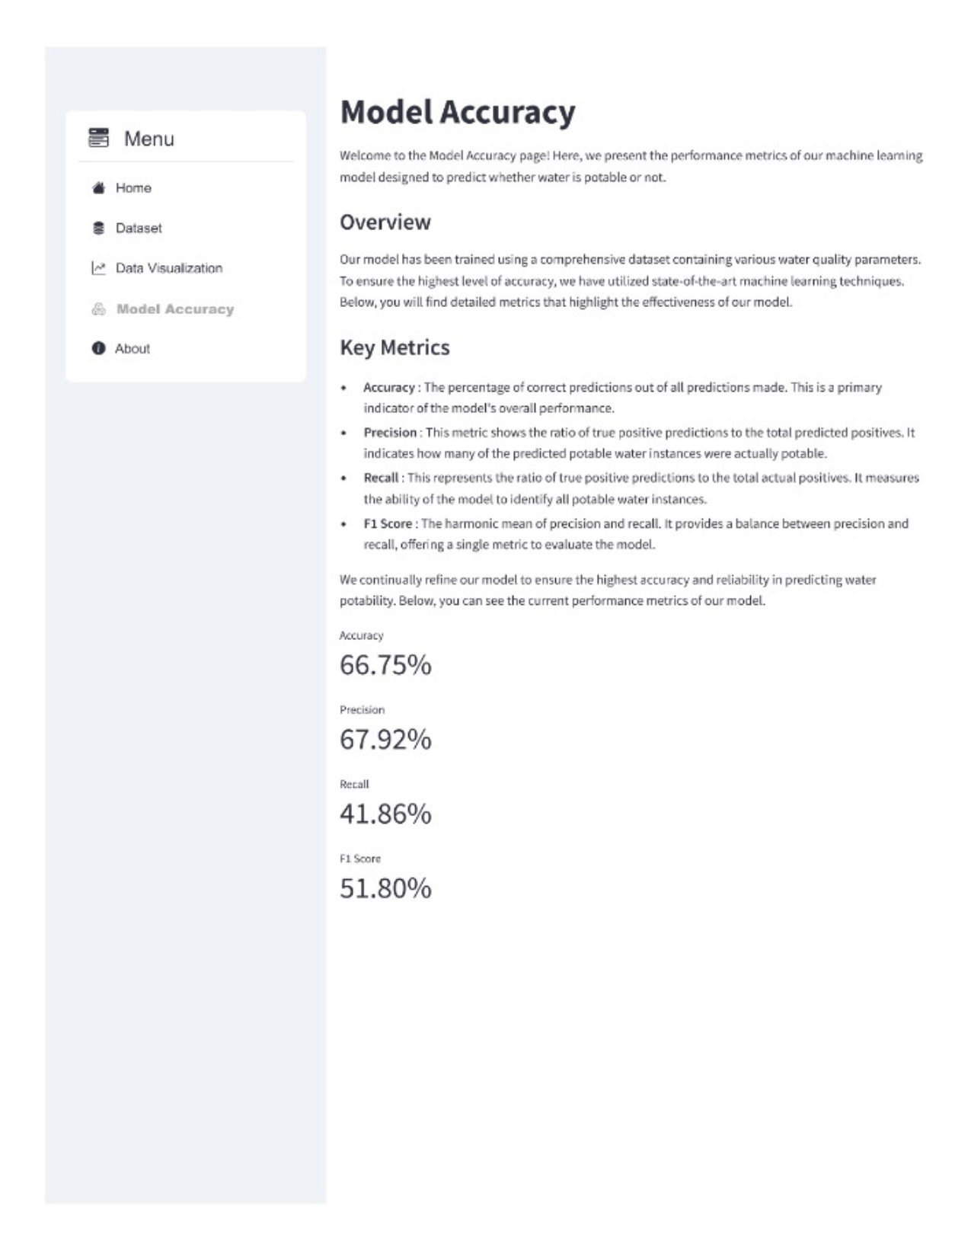

9 Model Performance Metrics

###### 4.2.2 Data Visualization

* **Description:** Data visualization helps in understanding the distribution and correlation of different water quality parameters. By generating histograms and bar charts, we can identify patterns and relationships that influence water potability. These visualizations provide insights into how each parameter affects the overall water quality.
* **Screenshot:**

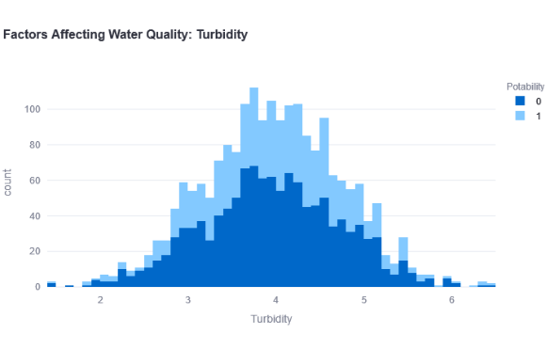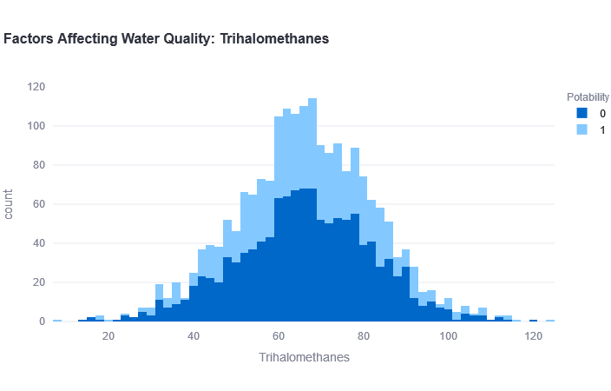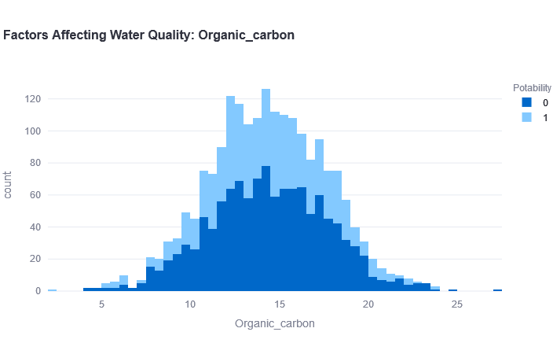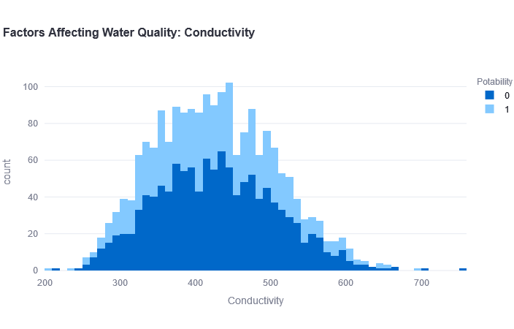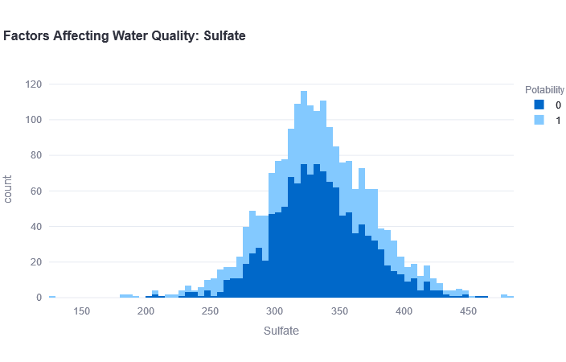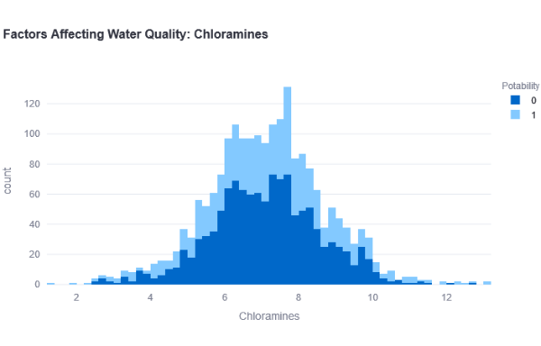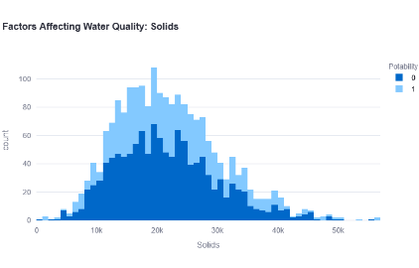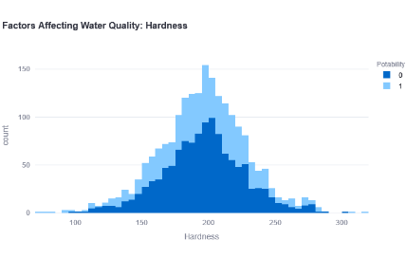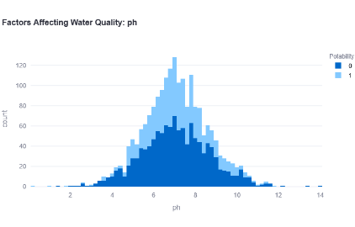

10 Factors Affecting Water Quality

###### 4.2.3 User Interface

* **Description:** The user interface is designed to be intuitive and easy to navigate. Users can input water quality parameters, view the dataset, explore data visualizations, and check model accuracy. The streamlined design ensures a smooth user experience, making it accessible to a wide audience.
* **Screenshot:**

**1. Home:**

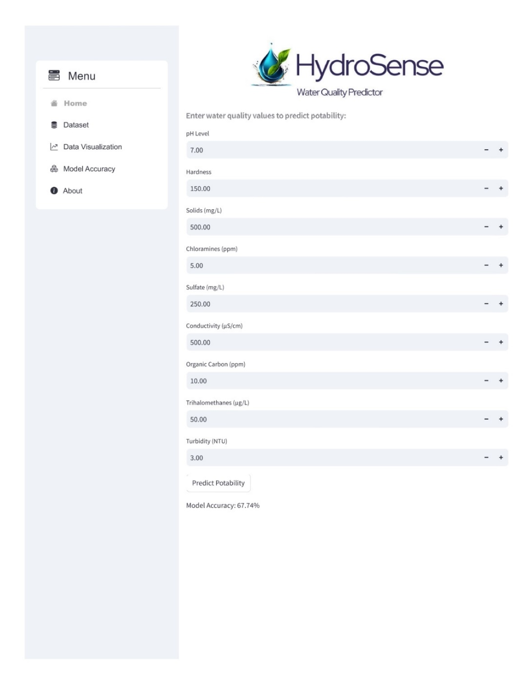

11 Home Page

**2. Dataset:**

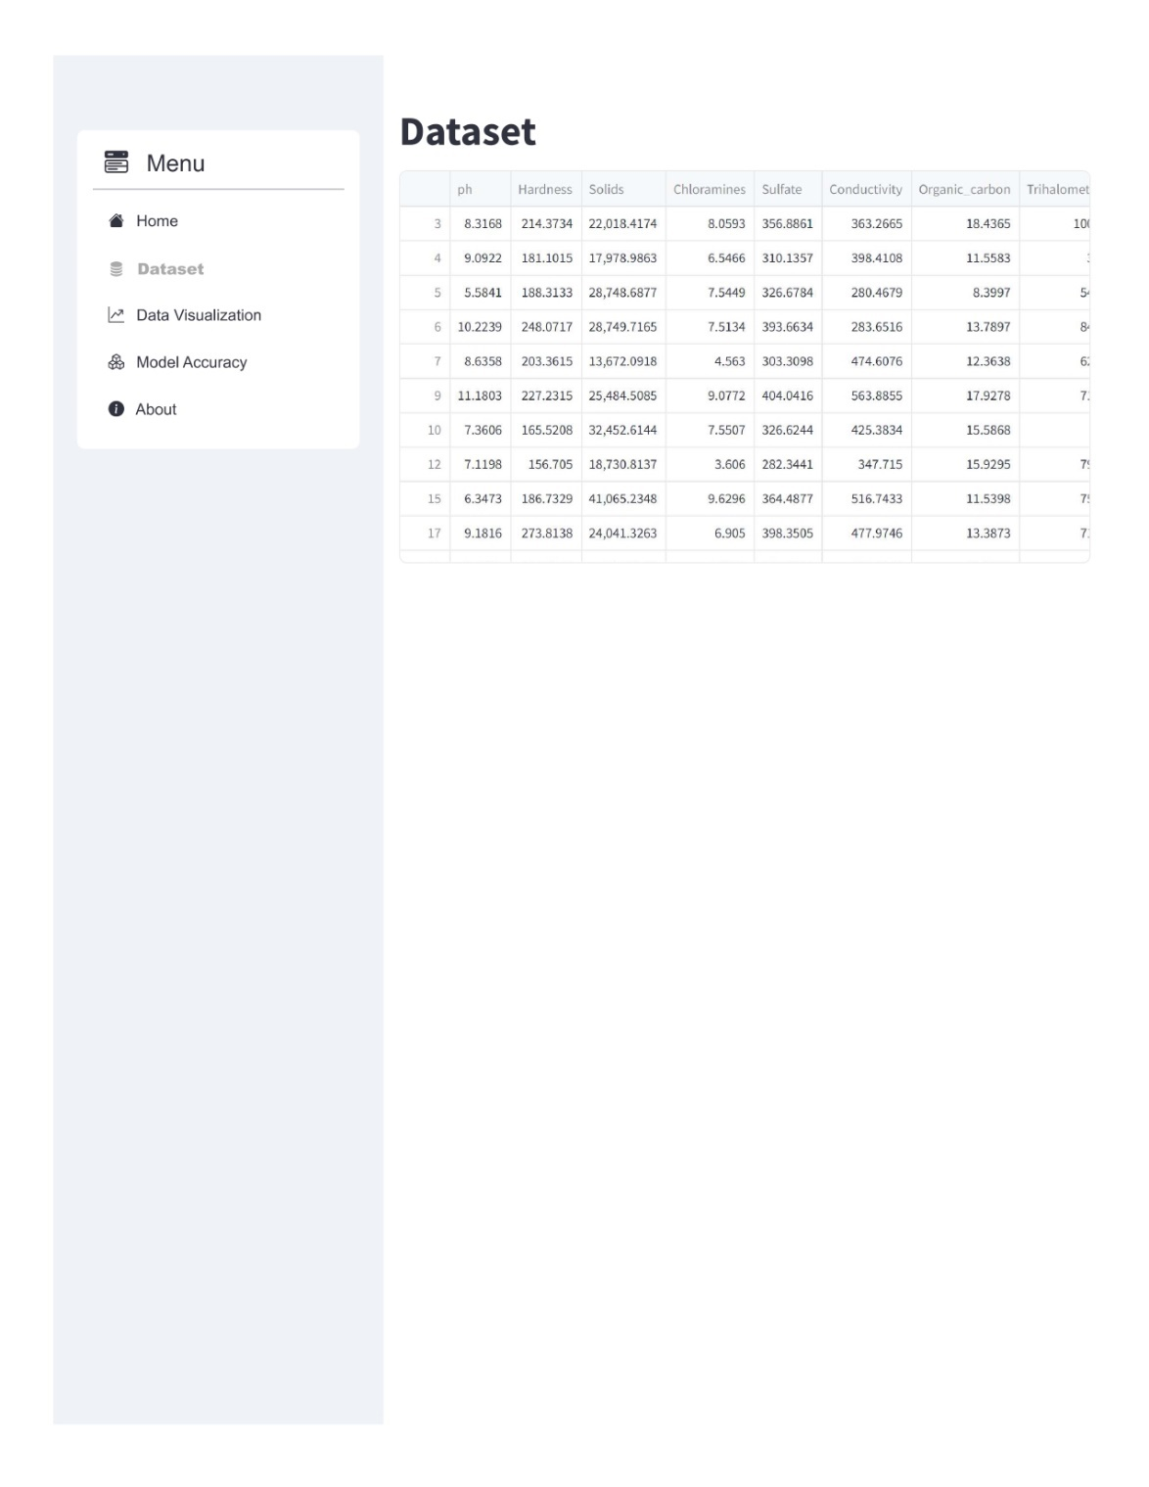

12 Dataset Page

**3. Data Visualization:**

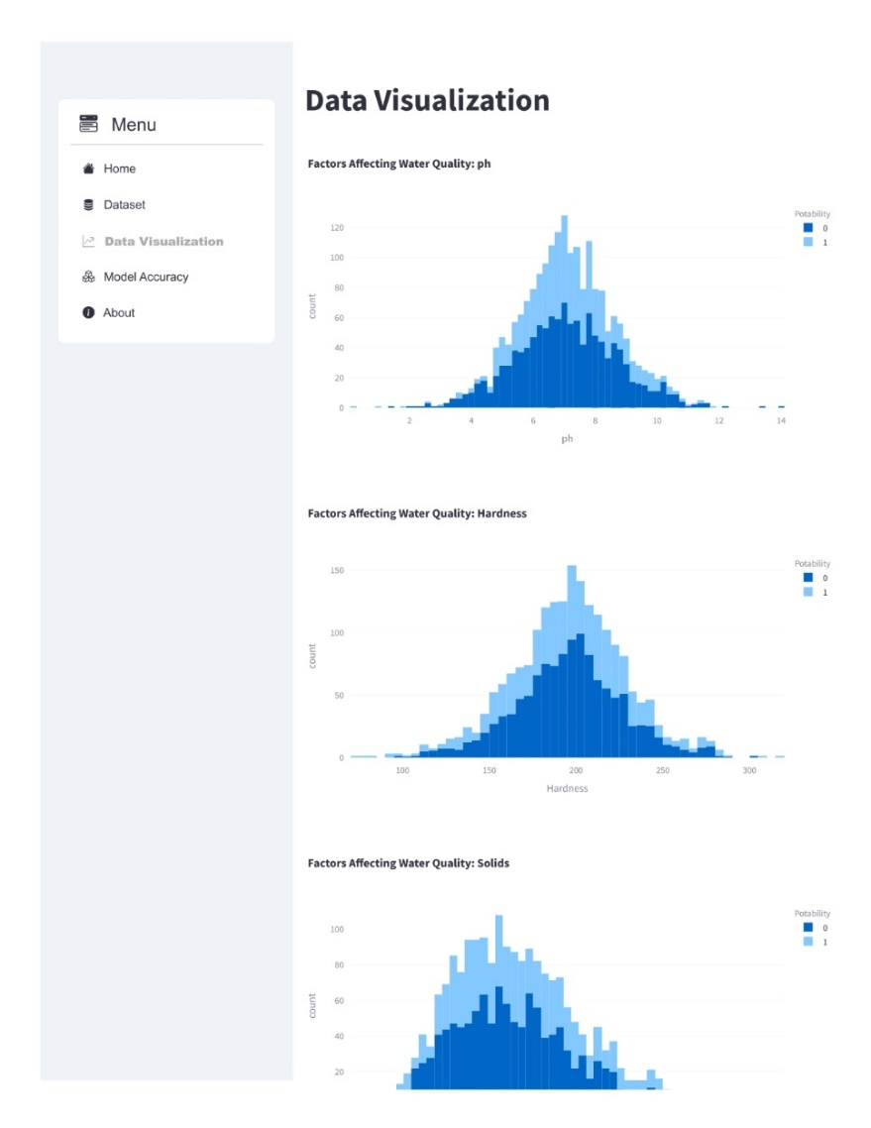

13 Data Visualization Page

**4. Model Accuracy:**

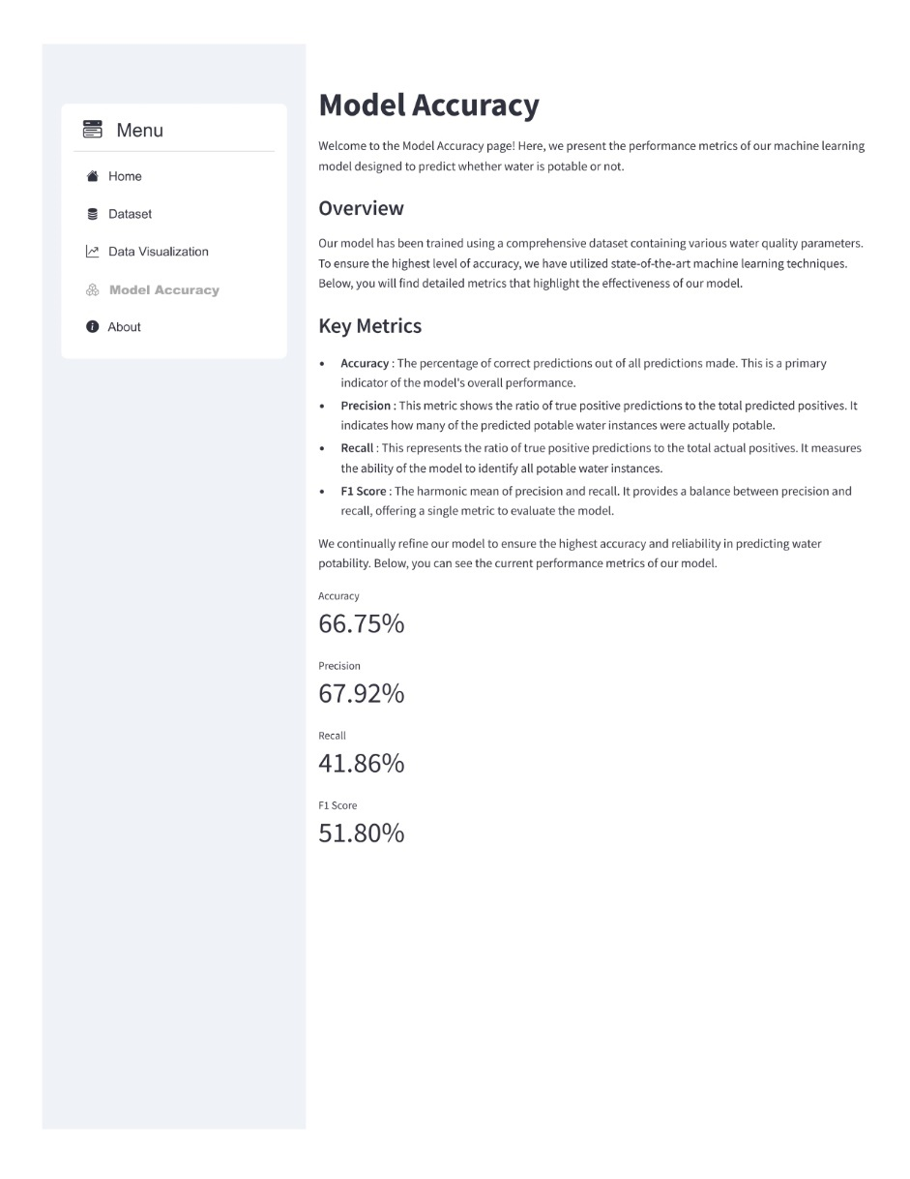

14 Model Accuracy Page

**5: About:**

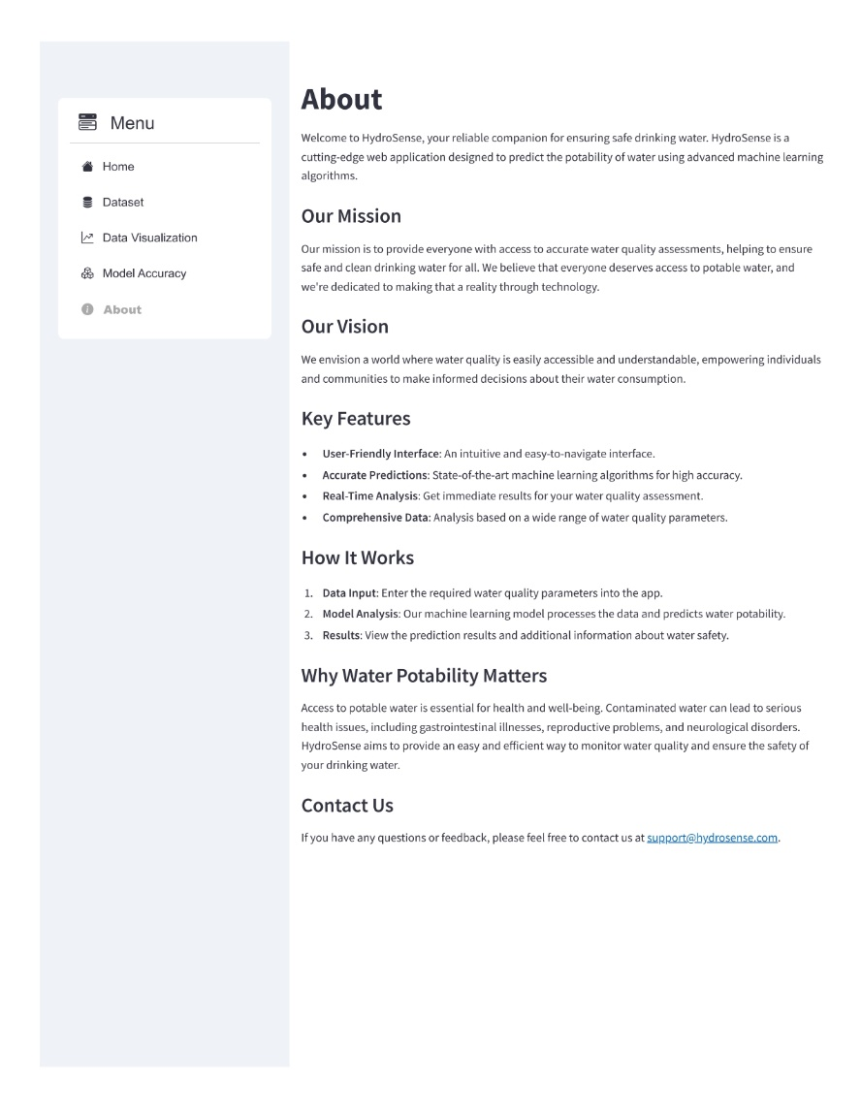

15 About Page

## Chapter 5. Conclusion

HydroSense is a web-based application designed to predict water potability using machine learning, specifically the RandomForest algorithm. Throughout the project, we have achieved significant milestones:

##### 5.1 Contributions to the Field

HydroSense contributes to the field of water quality assessment in several ways:

**1. Accessibility:** The web-based application makes it easy for users to access water quality predictions without requiring extensive technical knowledge.

**2. Accuracy:** The use of the RandomForest algorithm ensures high accuracy and reliability in predicting water potability, providing users with confidence in the results.

**3. Data-Driven Decisions:** By providing immediate feedback on water quality, HydroSense empowers users to make informed decisions about their water consumption, potentially preventing health issues related to contaminated water.

**4. Educational Value:** The application also serves as an educational tool, helping users understand the importance of various water quality parameters and their impact on potability.

##### 5.2 Limitations

Despite its strengths, HydroSense has some limitations:

**1. Data Dependency:** The accuracy of predictions depends heavily on the quality and comprehensiveness of the dataset used for training. Any gaps or biases in the data can affect the model's performance.

**2. Parameter Range:** The application relies on a specific range of water quality parameters. Any inputs outside this range may lead to inaccurate predictions or errors.

**3. Model Interpretability:** While RandomForest provides high accuracy, it is inherently a black-box model, making it difficult to interpret the underlying decision-making process.

##### 5.3 Future Scope

Future enhancements to HydroSense could address the current limitations and expand its capabilities:

**1. Expanded Dataset:** Incorporating more diverse and comprehensive datasets can improve the model's accuracy and robustness.

**2. Feature Expansion:** Including additional water quality parameters or external factors such as geographical location and weather conditions can enhance prediction accuracy.

**3. Model Interpretability:** Integrating explainable AI techniques can provide users with better insights into how the model makes predictions, increasing transparency and trust.

**4. Mobile Application:** Developing a mobile version of HydroSense can make it even more accessible, allowing users to assess water quality on the go.

**5. Real-Time Data Integration:** Connecting the application to real-time water quality monitoring systems can provide users with up-to-date assessments, further improving the practicality of HydroSense.

##### 5.4 Conclusion

HydroSense represents a significant advancement in the field of water quality assessment, leveraging machine learning to provide accurate and timely predictions of water potability. The development of the application demonstrates the power of data-driven approaches in addressing critical environmental health issues. While there are limitations to address, the potential for future improvements and expansions is vast. HydroSense not only empowers individuals and communities to make informed decisions about their water consumption but also contributes to broader efforts in ensuring access to safe drinking water for all. By continuing to refine and expand the capabilities of HydroSense, we can make a meaningful impact on public health and environmental sustainability.

## REFERENCES

1. **scikit-learn:** Machine Learning in Python. (n.d.). Retrieved from <https://scikit-learn.org/>
2. **Streamlit:** The fastest way to build and share data apps. (n.d.). Retrieved from <https://streamlit.io/>
3. **Plotly:** The leading front-end for ML & data science models. (n.d.). Retrieved from <https://plotly.com/>
4. **UCI Machine Learning Repository**. (n.d.). Water Potability Dataset. Retrieved from <https://archive.ics.uci.edu/ml/datasets/water+potability>
5. **Streamlit Documentation.** (n.d.). Retrieved from <https://docs.streamlit.io/>

## Appendix

##### Appendix A: Dataset Description

**Water Potability Dataset**

The Water Potability Dataset contains the following columns:

1. **pH**: The pH level of the water. A measure of how acidic or basic the water is.
2. **Hardness**: A measure of the concentration of calcium and magnesium in the water.
3. **Solids**: The amount of dissolved solids in the water, measured in mg/L.
4. **Chloramines**: The concentration of chloramines in the water, measured in ppm.
5. **Sulfate**: The concentration of sulfate in the water, measured in mg/L.
6. **Conductivity**: The electrical conductivity of the water, measured in μS/cm.
7. **Organic Carbon**: The amount of organic carbon in the water, measured in ppm.
8. **Trihalomethanes**: The concentration of trihalomethanes in the water, measured in μg/L.
9. **Turbidity**: The cloudiness of the water, measured in NTU.
10. **Potability**: The target variable indicating whether the water is safe to drink (1) or not (0).